CE 4910 Senior Design Project I

Senior Design Project Title

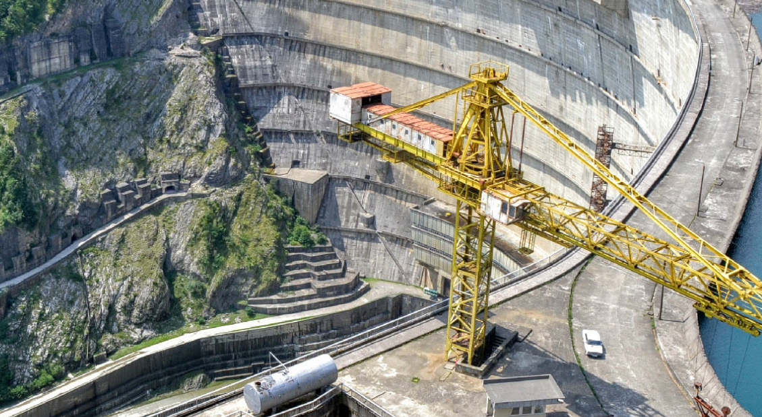
Name Surname (14 PT)

July 2022

İZMİR

Table of Contents Page

Table of Figures iii

List of Tables iv

List of Abbreviations v

1. introduction 6

1.1 Secondary Title 7

2. Primary Tıtle 8

Table of Figures

Figure 5-2 Sample Figure 7

List of Tables

Table 1-1 Sample Table 6

List of Abbreviations

ASTM : American Society for Testing and Materials
AWWA : American Water Works Association

introduction

Table 1-1 Sample Table (11 Punto)
 | Summer | Winter
Density
Excess Temperature, ΔT
Discharge Temperature
Kinematic Viscosity

Figure 5-2 Sample Figure (11 Punto)

Secondary Title (12 Punto CAMBRIA)

Primary Tıtle (12pt Cambria)

REFERENCES

